**Suggested Tutorial:**

**https://angular.io/tutorial**

**Github:**

1. I create two branches. I suggested everybody only works on develop branch:

$ git clone <https://github.com/XiaohuaCao/CattleGo.git>

$ git checkout develop (if you are not in develop branch)

Do this steps each time when you want to modify the code :

1. **git pull origin develop**
2. **modify your code**
3. **git add.**
4. **git commit -m “change …code”**
5. **git push origin develop**

Install environment

1. <https://nodejs.org/en/>
2. Install -g @angular/cli@1.5

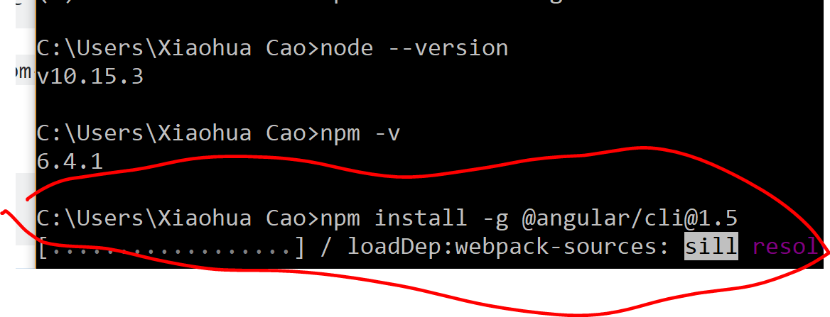

1. Download Microsoft visual code
2. Add path to environment:

You can also set the PATH manually by adding:

C:\Program Files (x86)\Microsoft Visual Studio

**Run code:**

1. 用vs editor 打开code： code .

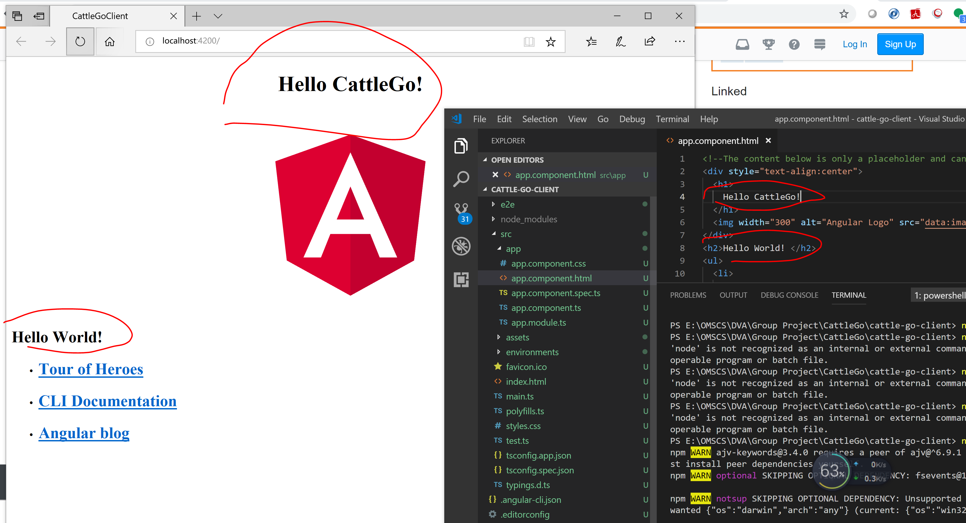

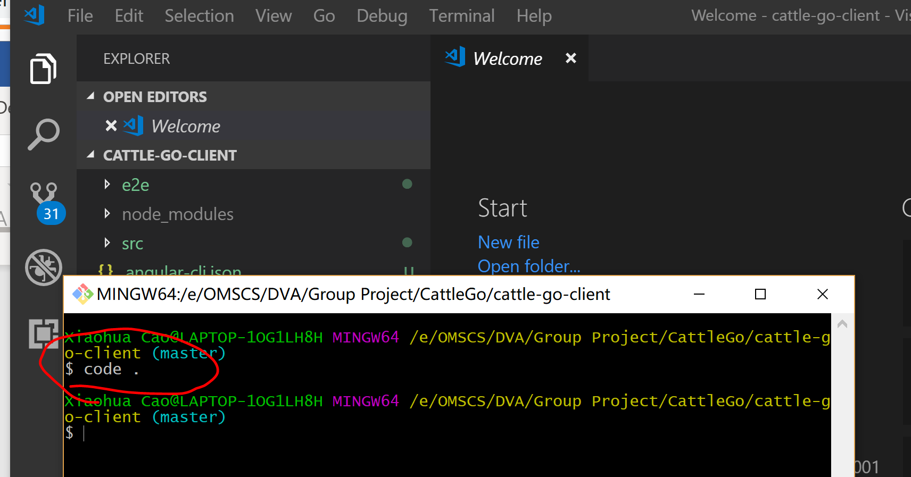

1. Result:

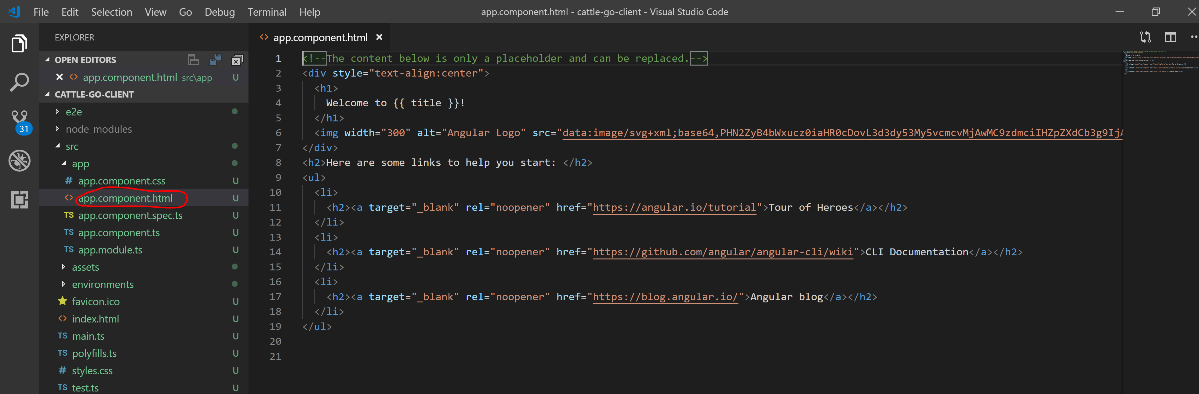

App component里 html就是我们得网页template